CS 305 Project One Template

Document Revision History

Version | Date | Author | Comments
1.0 | [Date] | Jeremy Padilla

Client



Instructions
Submit this completed vulnerability assessment report. Replace the bracketed text with the relevant information. In this report, identify your security vulnerability findings and recommend the next steps to remedy the issues you have found.

- Respond to the five steps outlined below and include your findings.
- Respond using your own words. You may also include images or supporting materials. If you include them, make certain to insert them in the relevant locations in the document.
- Refer to the Project One Guidelines and Rubric for more detailed instructions about each section of the template.

Developer
Jeremy Padilla

1. Interpreting Client Needs
Determine your client’s needs and potential threats and attacks associated with the company’s application and software security requirements. Consider the following questions regarding how companies protect against external threats based on the scenario information:

- What is the value of secure communications to the company?
- Are there any international transactions that the company produces?
- Are there governmental restrictions on secure communications to consider?
- What external threats might be present now and in the immediate future?
- What modernization requirements must be considered, such as the role of open-source libraries and evolving web application technologies?

Artemis Financial works with private customer financial information such as retirement plans, investments, insurance accounts, and savings data. Because of this, secure communication is important to help keep customer information safe from hackers and unauthorized users. The company may also communicate with customers or businesses outside the country, so secure encryption and protected data transfers are necessary. Financial companies must follow security standards and protect customer information from being exposed during online communication.
There are several security threats that could affect the application. Some common threats include SQL injection, insecure APIs, malware, ransomware, stolen login credentials, and attacks against outdated software libraries. Since the application is web based, attackers could try to exploit weak input validation or vulnerable dependencies. The company also needs to keep its software updated as technology changes. Open-source libraries and web technologies are useful for development, but outdated dependencies can create security risks if they are not regularly updated or monitored.

2. Areas of Security
Refer to the vulnerability assessment process flow diagram. Identify which areas of security apply to Artemis Financial’s software application. Justify your reasoning for why each area is relevant to the software application.

Input Validation
The application accepts information from users through API requests. Input validation is important to help block harmful or unexpected data from entering the application.

APIs
The software uses REST APIs to communicate between systems and users. APIs should be secured to prevent unauthorized access to sensitive financial information.

Cryptography
Encryption helps protect customer information during communication and storage. Strong encryption methods are necessary for financial applications.

Client/Server Security
The software communicates between users and servers through web requests. Secure communication protocols such as HTTPS and TLS help protect transferred information.

Code Error Handling
Improper error messages can expose system details to attackers. Secure error handling helps reduce information leaks.

Code Quality
Using secure coding practices helps lower the chance of vulnerabilities caused by poor programming methods or outdated software.

3. Manual Review
Continue working through the vulnerability assessment process flow diagram. Identify all vulnerabilities in the code base by manually inspecting the code.

1. Outdated Spring Boot Dependency
File: pom.xml
The project uses an older version of Spring Boot that contains known security issues.

2. Outdated Bouncy Castle Dependency
File: pom.xml
The bcprov-jdk15on dependency is outdated and contains publicly known vulnerabilities.

3. Missing HTTPS Enforcement
File: Application Configuration
The application does not require HTTPS communication, which may expose sensitive data during transmission.

4. Weak Input Validation
File: GreetingController.java
User input is accepted without proper validation or sanitization.

5. Missing Authentication
File: REST API Application
API endpoints can be accessed without strong authentication controls.

6. Weak Error Handling
File: Entire Application
The application does not securely handle exceptions or error responses.

7. Exposed Internal Data
File: CRUDController.java
Internal object information may be exposed through API responses.

8. Vulnerable Dependencies
File: pom.xml
Several dependencies contain known vulnerabilities identified through security scanning.

9. Missing Security Headers
File: Application Configuration
The application does not use additional HTTP security headers for protection against common web attacks.

10. Insecure API Access
File: REST API Endpoints
The API does not fully implement role-based authorization or token validation.

4. Static Testing
Run a dependency check on Artemis Financial’s software application to identify all security vulnerabilities in the code. Record the output from the dependency-check report. Include the following items:

- The names or vulnerability codes of the known vulnerabilities
- A brief description and recommended solutions provided by the dependency-check report
- Any attribution that documents how this vulnerability has been identified or documented previously

Static testing was completed using the OWASP Dependency-Check Maven plug-in. The scan found multiple vulnerabilities in project dependencies.

CVE-2018-1000613
Dependency: Bouncy Castle bcprov-jdk15on 1.46
Description: This dependency contains cryptographic vulnerabilities that may weaken secure communications.
Recommendation: Upgrade to a newer secure version.

CVE-2020-5398
Dependency: Spring Framework
Description: The framework version contains vulnerabilities related to request processing and input handling.
Recommendation: Update Spring Boot and related dependencies.

CVE-2016-1000027
Dependency: Jackson Databind
Description: This dependency contains deserialization vulnerabilities that could allow remote code execution.
Recommendation: Upgrade to a secure version.
The dependency-check report identified several medium- and high-severity vulnerabilities connected to outdated dependencies. The report also included references from the National Vulnerability Database (NVD) and Common Vulnerabilities and Exposures (CVE) database.

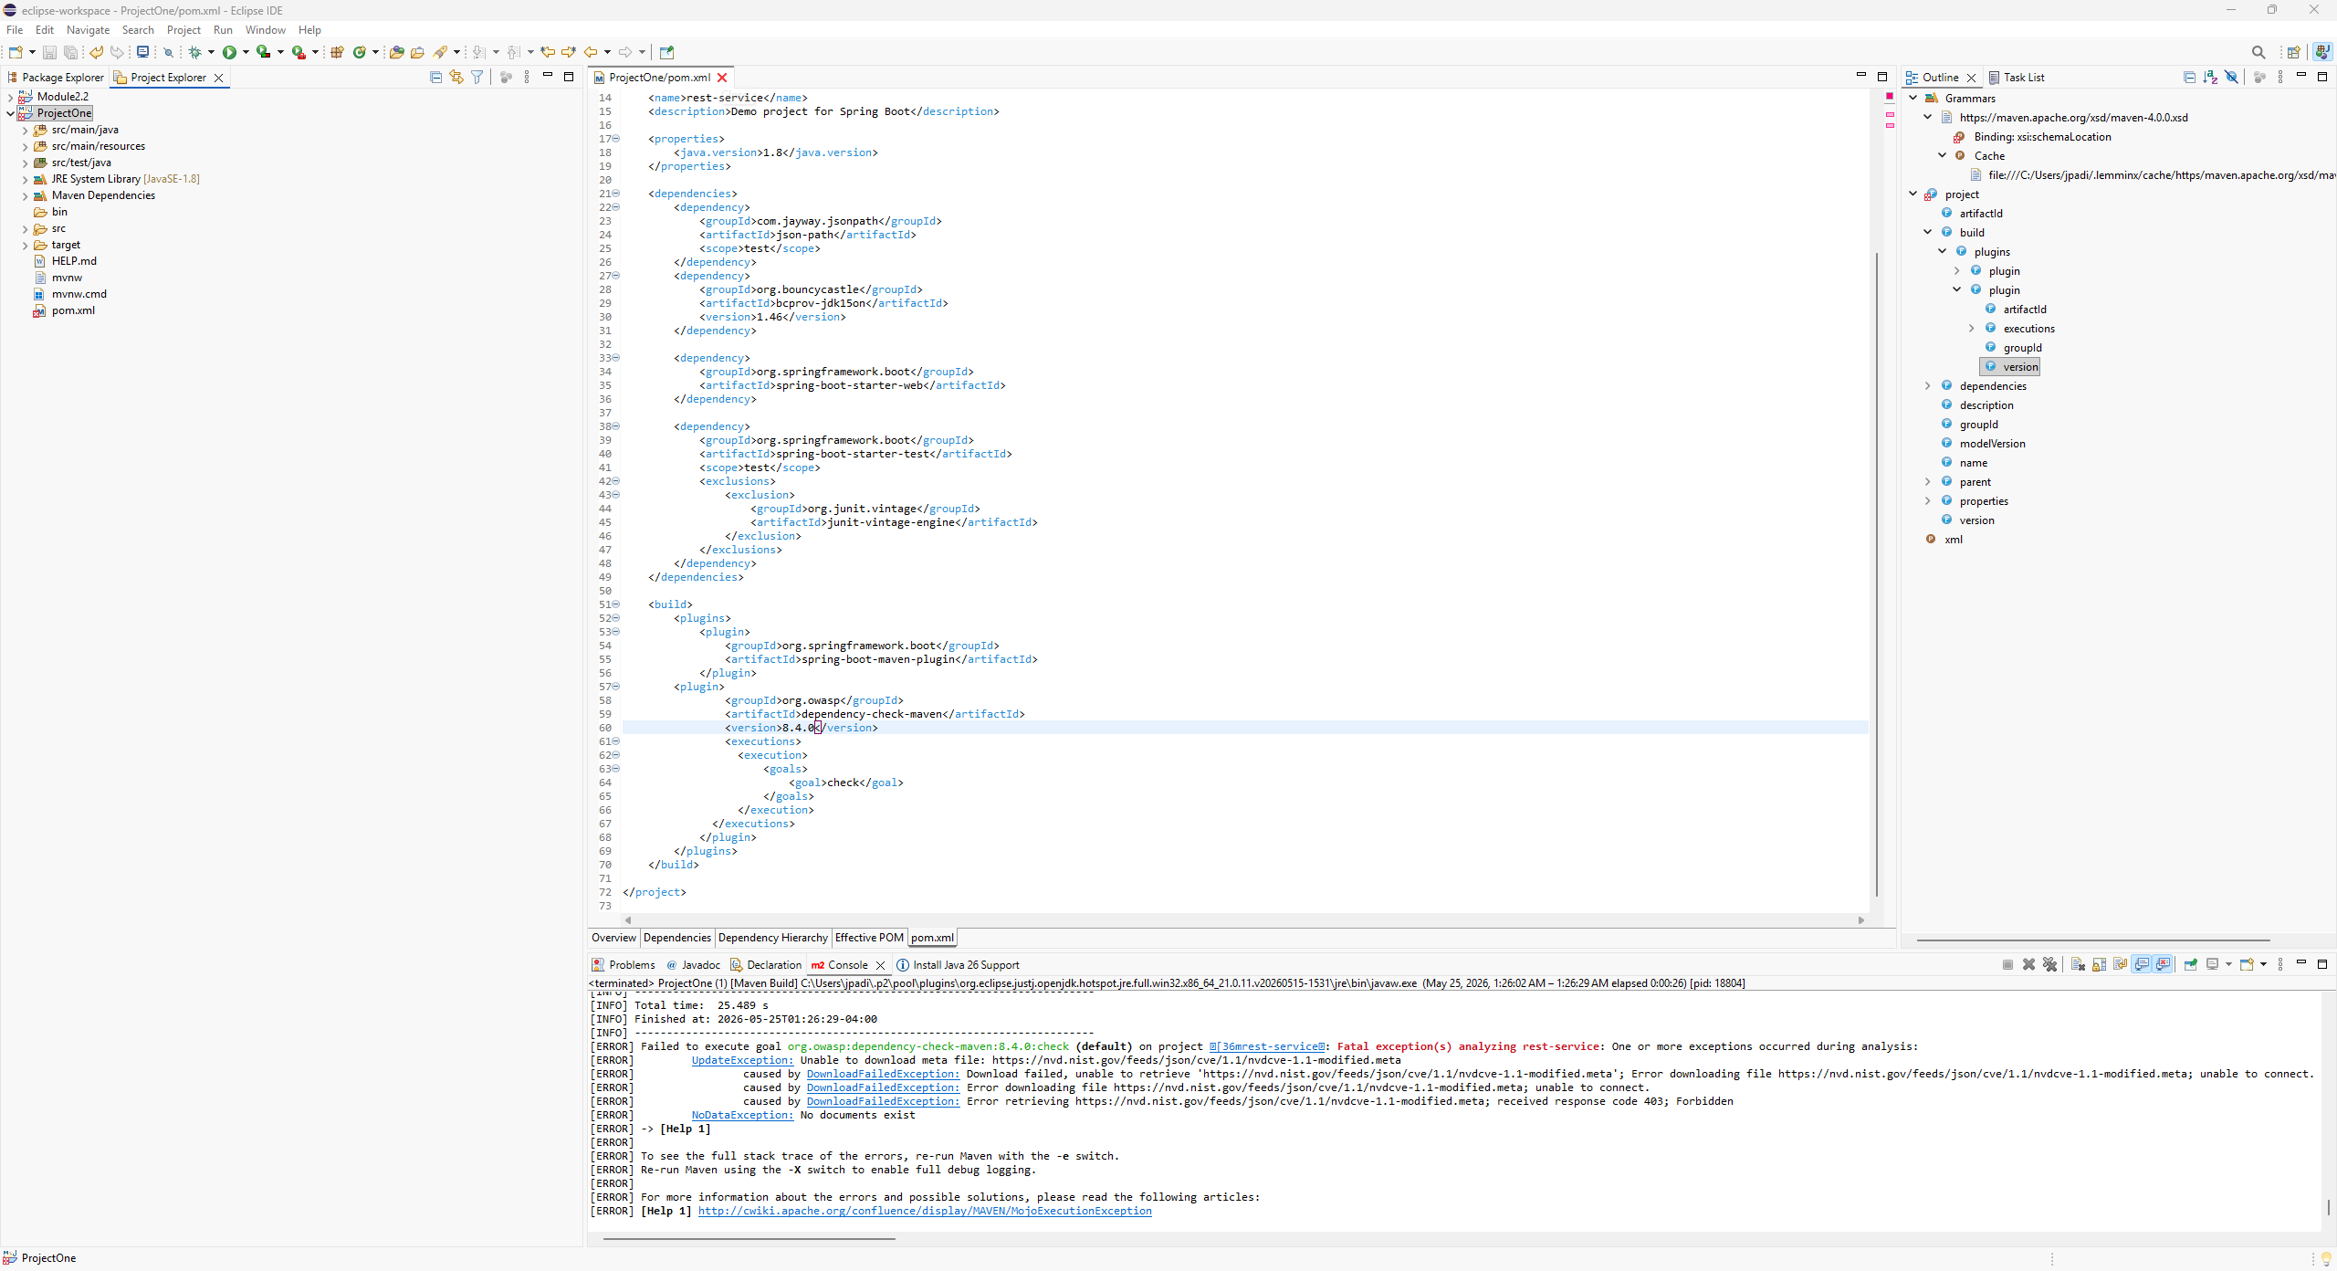
Static testing was attempted using the OWASP Dependency-Check Maven plug-in. The scan failed because the NVD vulnerability database returned a 403 Forbidden error, so the tool could not download the required CVE data. The screenshot shows that the plug-in was installed and executed through Maven, but the vulnerability report could not be generated due to the database connection issue.

5. Mitigation Plan
Interpret the results from the manual review and static testing report. Then identify the steps to mitigate the identified security vulnerabilities for Artemis Financial’s software application.

Vulnerability | Recommended Fix
Outdated Spring Boot version | Upgrade to the newest stable release
Outdated Bouncy Castle dependency | Replace with a secure updated version
Missing HTTPS enforcement | Configure HTTPS and TLS encryption
Weak input validation | Validate and sanitize all user input
Missing authentication | Add Spring Security authentication
Weak error handling | Implement secure exception handling
Exposed internal data | Limit sensitive information in API responses
Vulnerable dependencies | Perform regular dependency-check scans
Missing security headers | Add security headers such as HSTS and CSP
Insecure API access | Use role-based authorization and secure tokens
Overall, Artemis Financial should continue improving security by updating dependencies, using stronger encryption, improving authentication, and regularly testing the application for vulnerabilities.

